**How to save topography data with “grd” format in SPEEDY**

**Step by Step Instruction**

**SPEEDY version:** 41

**Original version developed by:** Fred Kucharski, Franco Molteni, and Martin P. King

**1. Make sure that the “NetCDF” file you made satisfy the reading regulation of GrADS**

If you have a message of “*SDF file has no discernable X coordinate*,” please refer to Figure 1.

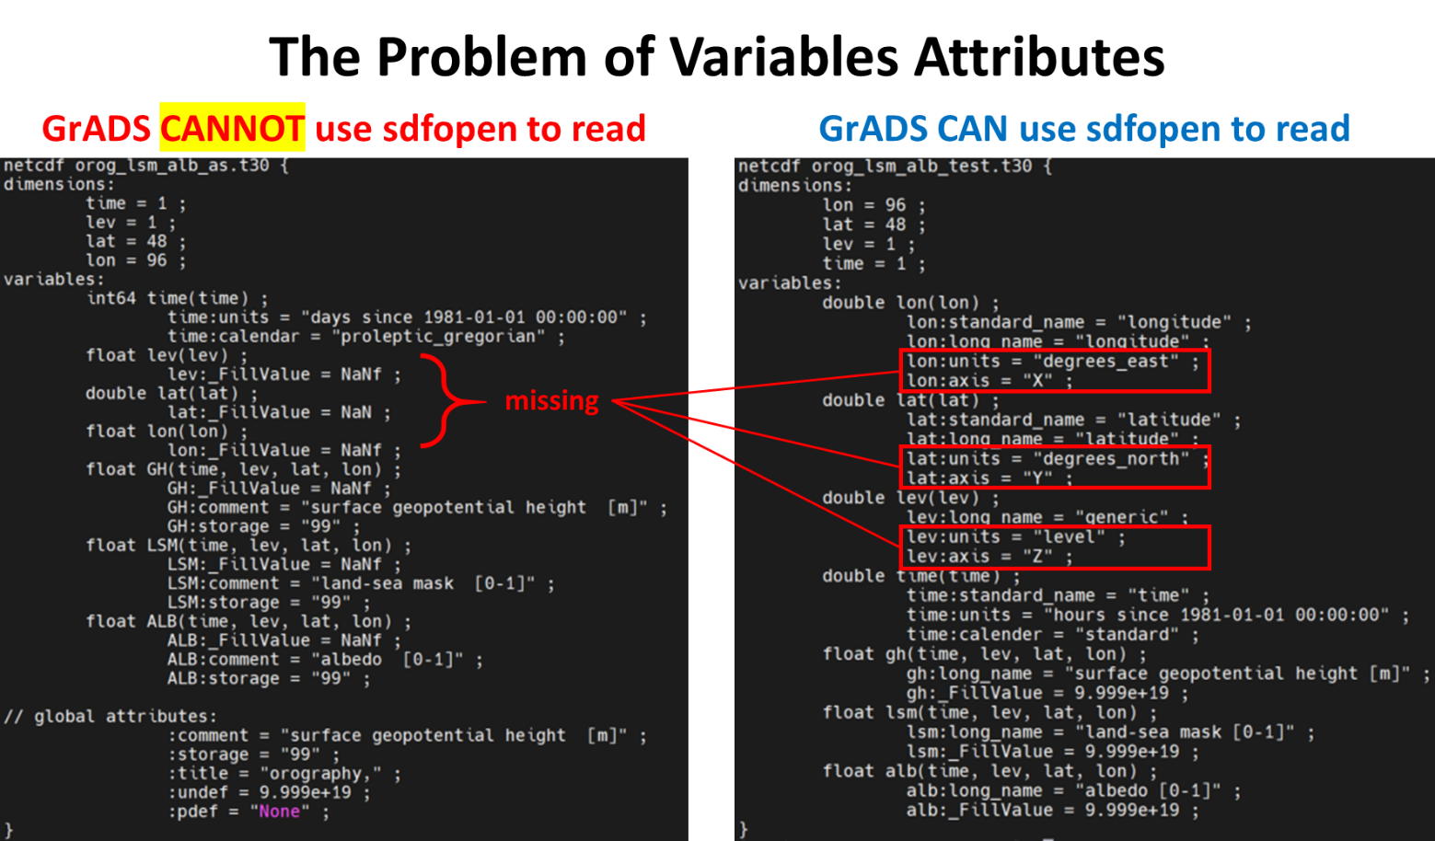

**Figure 1.** The problem of variable attributes.

**2. Creat “grd” file by using GrADS: step1_write_nc2grd.gs**

Using GrADS to read in NetCDF file and output “grd” file. This step can successfully create a “grd” file that GrADS can read. However, the y-dir of this file is upside-down. We need next step to reverse it.

**INPUT:** the NC file you prepared (e.g., orog_lsm_alb_text.t30.nc)

**OUTPUT:** orog_lsm_alb_test.t30.ydir.grd

In addition, you will need to copy a “ctl” file for next step.

**CTL:** orog_lsm_alb_test.t30.ydir.ctl (Figure 2)

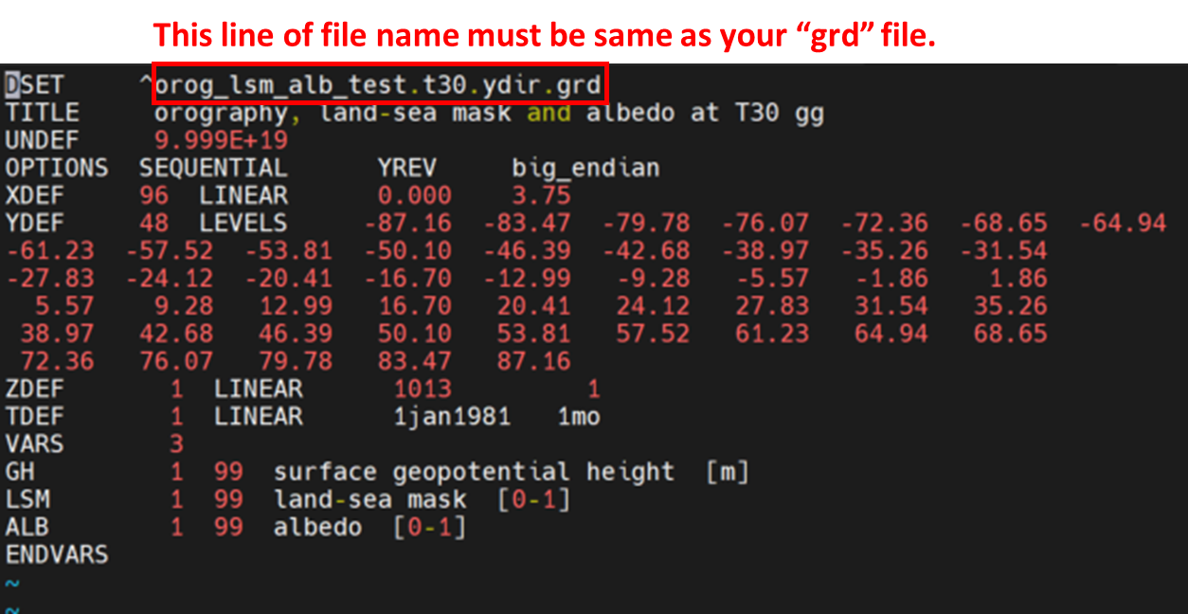

**Figure 2.** The “ctl” file used in the next step.

**3. Reverse y-dir by using GrADS: step2_reverse_ydir.gs**

Using GrADS to read in “grd” file with the “ctl” file we created in previous step.

**INPUT:** orog_lsm_alb_test.t30.ydir.grd & orog_lsm_alb_test.t30.ydir.ctl

**OUTPUT:** orog_lsm_alb_test.t30.grd

You also need to create another “ctl” file for GrADS to read the final “grd” file.

**CTL:** orog_lsm_alb_test.t30.ctl